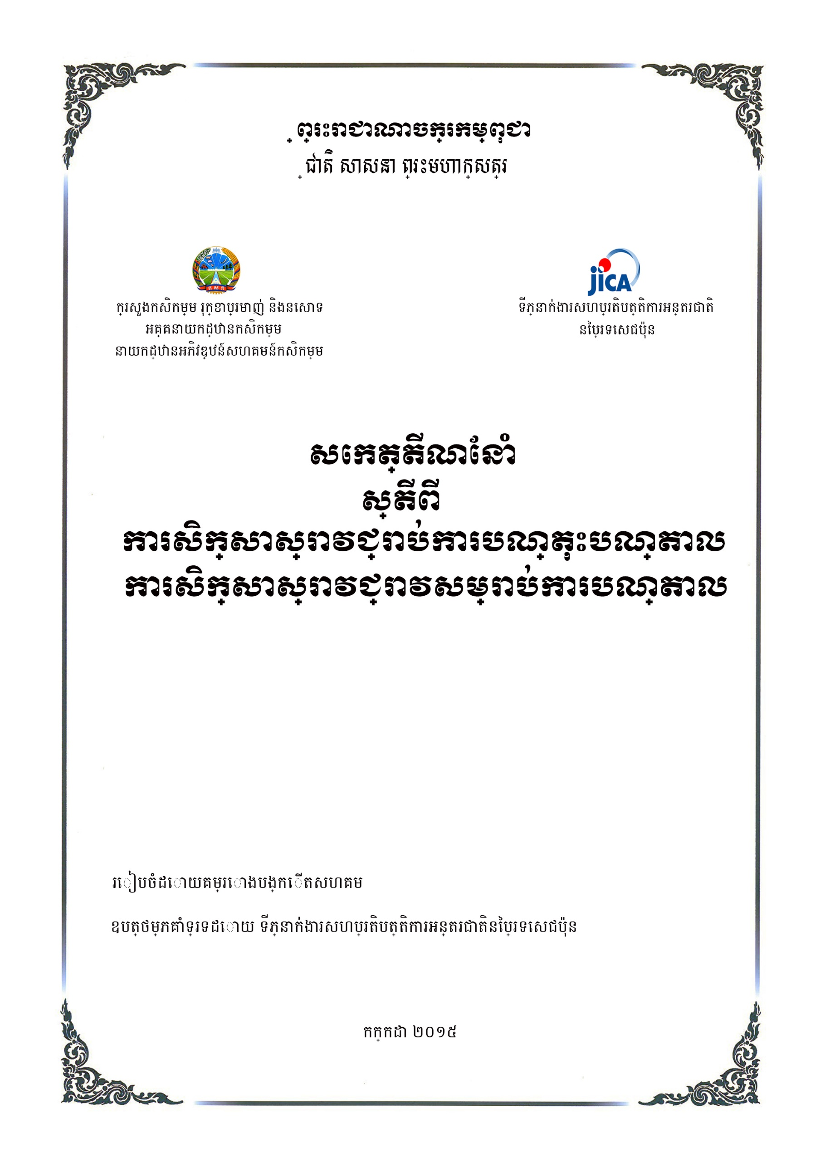
Prepared by: Project for Establishing Business-Oriented Agricultural Cooperative Models (BPAC)

April, 2017
Ministry of Agriculture, Forestry and Fisheries
General Directorate of Agriculture
Department of Agricultural Cooperative Promotion

Guideline on Credit Management
Of Agricultural Cooperative

Draft, 24 July, 2017

Kingdom of Cambodia
Nation Religion King
3
Content
Chapter I
Concept of Credit Business of Agricultural Cooperative
- Saving Account
  - Ordinary Saving
  - Fixed-Term Saving
- Loan Provision
2.1 Loan Overview
2.2 Lending Conditions
2.3 Lending Products
2.4 Term of Loan
2.5 Loan sizes

Chapter II
Procedures of Saving of Agricultural Cooperative

1. Procedure of Ordinary Saving
1.1 Opening Saving Account Process
1.2 Saving Account Term and Conditions
2. Procedure of Fixed-Term Saving
2.1 Term Deposit Account Opening Process
2.2 Term Deposit Term and Conditions

Chapter III
Process of Loan Provision of Agricultural Cooperative
1. Process of Loan Provision of Agricultural Cooperative
Step1. Submission of Loan Application and collection of concerned documents
Step2. Assessment and recommendation of Credit Agent
Step3. Recommendation from Vice-Chairman of Credit Committee
Step4. Approval of Credit Committee Meeting
Step5. Letter of Granting loan / Loan Offer Letter
Step6. Loan Contract/ Agreement
Step7. Disbursement Loan
Step8. Filling Loan Document
2. Loan Monitoring
3. Loan Delinquency
4. Loan Recovery

Chapter I
Concept of Credit Business of Agricultural Cooperative
Generally, an agricultural cooperative runs credit business in order to support members in agricultural production, agri-business, or services related to agricultural production aimed to enhance their economic, social, and culture in accordance with Law on Agriculture Cooperative.
Credit business of agricultural cooperative is divided into two such as saving and loan.
- Saving
Running credit business, agricultural cooperatives around the world such as Japan, Thailand, Malaysia, and other countries, principally use saving to provide loan by not using share capital to give loan. Therefore, agricultural cooperatives in Cambodia should follow above principle by persuading members to put saving so that ACs can have capital to run credit business.
There are two types of saving such as Ordinary Saving and Fixed-Term Saving.
  - Ordinary Saving
Ordinary Saving a type of saving that has very few interest as depositor can withdraw their money any time. Ordinary Saving allows AC members to accumulate interest on funds they have saved for future needs. Interest rates can be compounded on a daily, weekly, monthly, or annual basis. Ordinary Saving varies by interest rates, method used to calculate interest, and minimum opening deposit.
AC is very difficult in calculating interest for this Ordinary Saving because a large number of ACs in Cambodia do calculation by hand not computer.

  - Fixed-Term Saving
Fixed-Term Saving is a kind of saving with higher interest rate with fixed period of time. The first thing to notice when choosing a Fixed-Term Saving is the interest rate. This lets you work out how much interest you will earn over the life of your Fixed-Term Saving, and the higher the interest rate, the more your savings will grow. Unlike a savings account, Fixed-Term Saving has a fixed rate, so market changes won’t affect your earnings.
Depositors are not able to withdraw their money until maturity such as 3 months, 6 months, and 12 months. In case they withdraw their money before maturity, they cannot receive any interest.
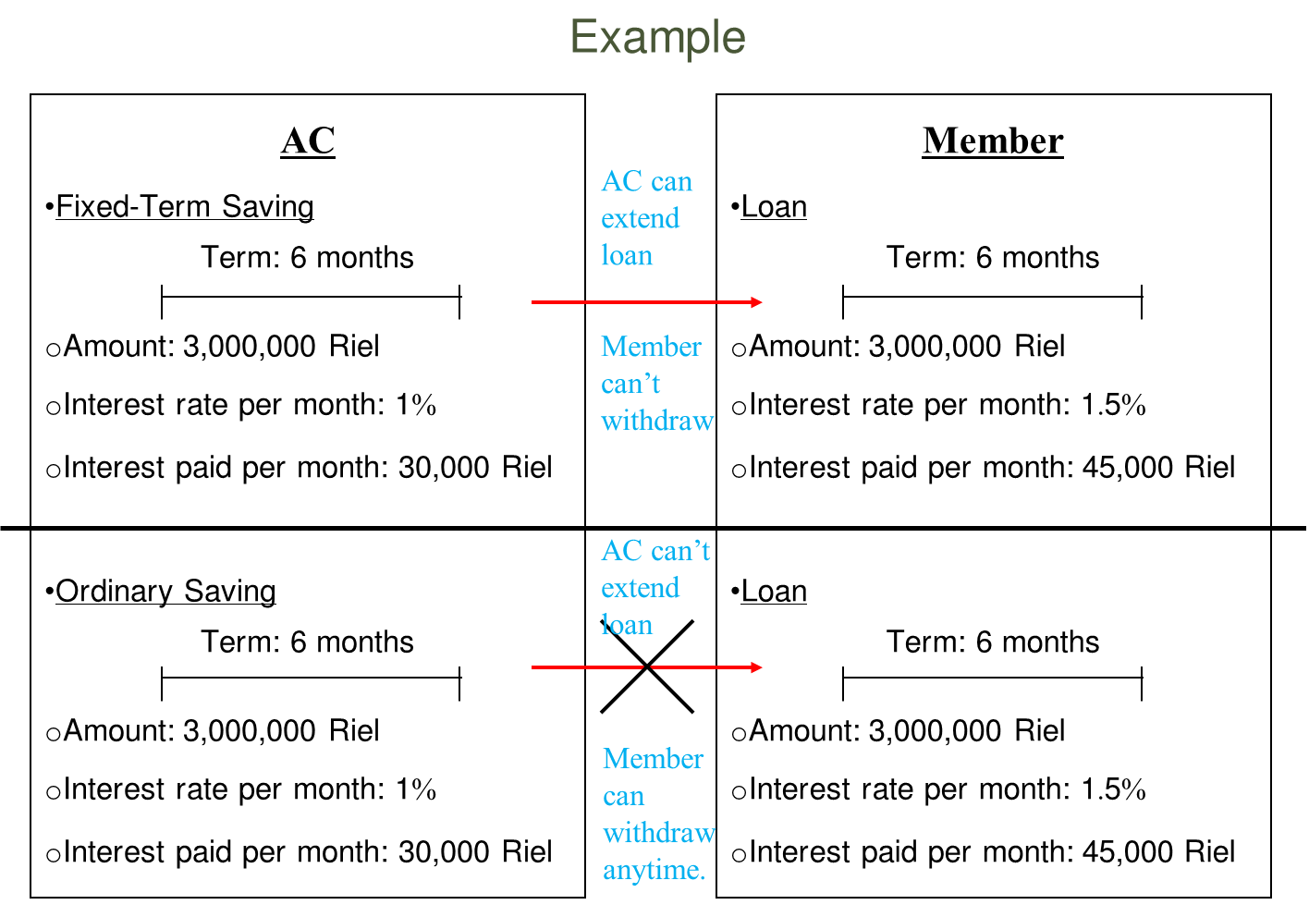
AC should convince members to put Fixed-Term Saving so that AC can use that money to run businesses; AC is also easy to calculate interest for depositors.

- Loan Provision
  - Loan Overview in AC
Loan is a debt that borrower has to return following with loan condition and agreement between loan provider and borrower. Loan can cause positive results and negative results to borrower depending on his/her usage whether loan is used in accordance with loan objective.
In agricultural production or business, it is necessary to have capital to invest on the business borrower aims to run. For AC member, factors to get successful is that AC member shall know the time to use loan, which is a good solution to cope with condition that borrower lacks fund.
It is not a good idea to get loan from bank or microfinance or lending institution if borrower does not have a clear objective in using loan to get benefit because it will make borrower unable to return the loan to provider. In some cases loan providers will confiscate house or land or other properties which is put as collateral.
Regarding the acceptance of loan from AC, if member does not have a clear objective in agricultural production or other businesses to get profit, he/she must not get loan from AC since it can make him/her unable to return loan to AC.
In contrast, if AC members lack capital but have a clear objective on their business, they shall request for loan at AC to run their business because it will make AC members get profit from the business and be able to return loan to AC, which will improve the living standard of AC members.
  - Lending Conditions
At present, agricultural cooperatives engage in various types of business in responding to their member’s needs such as providing loan to all members for productive and providential purposes at affordable interest rates , encourage members' thrift through savings and deposits. To simplify, the entire product is significantly designed only for the AC members who are currently members of agriculture cooperative that require capital to support their business related to agriculture. Simply, agricultural cooperative offers loan to members of AC that generate seasonal income such as animal-raising, vegetable growing, or rice farming, etc.

  - Lending Products
    - Individual loan:
An amount of loan given with single application. The downside is that it is usually for small amounts, typically not going over KHR 20,000,000.
    - Group loan:
Loans given to groups, that is, either to individuals who are member of a group and guarantee each other's loan or to group that then sub-loan to members. Under this type of loan, would-be AC members form groups (usually 5 or more) within which each member agrees to guarantee the loans of other in the group. If anyone in the group defaults on his or her loan, the other members of the group are required to cover the short fall loan amount. The loan size is not fixed; it depends on internal regulation of each AC.

  - Term of loan
    - Short Term Loan:
Short term loan is not more than 12 months. This loan’s purpose is for using as business expansion and/or as working capital to purchase seeds, fertilizer, chemical ,work animal, equipment used in operations farm or labor expenses, in relation to land preparation, planting, harvesting, …etc. The repayment method can be bullet payment or installment. It is based on our AC member’s payment ability (cash flow), yet it mostly go to bullet repayment one, and short term loan likely to have high interest rate comparing to any others.
    - Long Term loan:
Loan in which the duration of this loan is more than 12 months. Long term loan is commonly used for purchasing heavy agricultural machinery, improving irrigation systems, soil conservation and land reclamation…etc. Usually, the payment method of this loan is normally on an amortizing basis but we sometimes can provide the grace period for the first three or six months of the total term of loan. Of course, the obvious advantage of long term loan is the interest rate most likely lowers than the short term one, plus other good term and conditions are generally negotiable or offered.

  - Loan Sizes
In normal practice of micro-finance institutes, loan sizes have been divided into three sizes as:
    - Small Loan:
Loans provided to AC members to use for farming or business support that have low income. These loans may have less restrictive requirements and its amount is generally from 500,000KHR to 4,000,000KHR.
    - Medium Loan:
Loans provided to AC members who have medium income from farming and its amount is from 4,000,100KHR to 40,000,000KHR.
    - Large Loan:
Loans provided to AC member having business or farming with high income, have good cash flow. Normally, large loan process is a bit hard to get since it may require AC member to prepare a lot of supporting documents in order to get the loan approved. The amount is from 40,000,100KHR to 400,000,000KHR.
Chapter II

Procedures of Saving of Agricultural Cooperative

There are two types of saving of agricultural cooperative such as Ordinary Saving and Fixed-Term Saving.
- Procedure of Ordinary Saving
  - Opening Ordinary Saving Account Process
Opening Ordinary Saving account with agricultural cooperative is not complicated, we will need to process a few step only, and then AC members will have one saving account with a saving book in hand. Each step is less restricted comparing to lending process. The first step for opening account is to understanding the required document for account opening which are:
    - Step 1: Required Document for Account Opening

Below are the required documents that AC member need to have at least one of them for opening Ordinary Saving account:
  - National Identity Card
  - Passport
  - Family Record Book/ Resident Book
  - Civil Servant ID card
  - Driving License
  - Birth Certificate
*Note: Please make sure that all the document is in validity.

    - Step 2: Opening Account Application
In this step, agricultural cooperative staffs will ask AC members some information in order to fill in the opening account applicant form below. Agricultural Cooperative staffs ensure all the information is real and properly completed. Then, agricultural cooperative staffs may inform AC members the minimum deposit amount for saving account opening either they want to deposit only the minimum or more than that. In this step, the agricultural staffs may take time to guide AC members how to use saving account with the saving book properly and some other term and conditions of this account to the AC members as needed.
Kingdom of Cambodia
Number of client: …………………

Nation Religion King
*********
Deposit Application Form

- Mr. / Ms. : ………………………., sex: ………., year of birth: …………….., nation:…..., nationality: Khmer, holds identification card (ID) number:………………………….., dated on: ………….., issued by: …………….., personal occupation: ………….., duration: ……………, place:…………….
- Spouse. : ……………………….., sex: ……….., year of birth: ………., nation: ……, nationality: Khmer, holds ID number ……………………….., dated on: ………….., issued by: ……., personal occupation: ……………………….., duration: …………, place: …………………..
- Marital status: single, married, widow, number(s) of dependent: ……… persons, income generator(s): ……….. persons
Current address: ................... village, ……………. commune, ……………. district, …………… province/city.
Telephone: ……………………..
Request to deposit:
Ordinary saving amounted to ………………………………. interest rate: ……… per month.
We certify that the above information is correct.
Prepare at: ………, date: ……………
Thumbprint of depositor
AC chairman

    - Step 3: Account Activate
When the Ordinary Saving account application has been properly completed, the agricultural staffs will have a quick check again in case some information missed or skipped. If everything is alright, the staffs bring the application to the supervisor, Vice-Chairman of Credit Committee, to sign as acknowledgement on the application. Then, it simply means the saving account can be used now. The AC members will get one saving book after that.

Kingdom of Cambodia

Nation Religion King

*******

Ordinary Saving Passbook

…………………………… Agricultural Cooperative

Name of person who put saving: Mr./Ms. ……………………………and Spouse………………………………..

Address: ……………….. village, ……………… commune, ……………….. district, …………… province.

Tel: ……………………………………………………………………………………………………..

Client No.: ……………………………………………………………………………………………………

Date: …………………………………………………………………………………………………………...

Withdrawing condition:​ One among above aforementioned names

All of aforementioned names
No. | Date | Deposit Amount | Withdraw Amount | Interest Amount | Balance | Signature of Recipient

  - Ordinary Saving Account Term and Conditions
When the account has been opened, it is compulsory that the AC members need to be well informed and understand all the term and conditions of the account that they are using so that when they come to do transaction with the agriculture cooperative they will not take much time and it also help them to use their account more properly.
    - Account Opening
- The AC members shall be responsible to carefully examine and ensure that the entries in their saving-book are correct and accurate each time before they leave the agriculture cooperative. If they fail to inform the agriculture cooperative any errors, discrepancies, claims or unauthorized debits or items in the saving-book within 14 days from the date of updating the saving-book, the AC member shall be deemed to have conclusively accepted all the entries in the saving-book as true and accurate in all respect.
- Replacement of lost saving-book will only be done at the agriculture office where the account was opened.
    - Deposit Conditions
- Deposits must be made into the account with saving-book.
- All deposits should be made using the passbook provided by the agriculture cooperative and the instructions contained therein shall be strictly observed.

    - Cash Withdrawal Conditions
- If AC members want to cash withdrawal, it must be made along saving book and the ID card or other equivalent supporting document.
- No third party withdrawal is allowed. Only those having name in the saving book could do the transactions.
    - Interest Rate Calculation for Ordinary Saving Account
- Interest at such rates as agriculture cooperative may specify shall be paid on the Ordinary Saving Account, in accordance with the prevailing practice of the agriculture cooperative.
- In case that interest rate is changed, AC shall put this change in Extraordinary General Meeting or Annual General Meeting to get approval from members, then AC should stick this information on AC’s whiteboard.
- Ordinary Saving account interests calculation formulas
- Interests on Ordinary Saving account are calculated using simple interest’s formula:
* Interest, I= P*r*t/365
- P-Money present in agricultural cooperative saving account
r- Savings account interest rates in % per annum
t – Time period (day) for which money is present in saving account.

Saving account interest calculation
- Suppose Mr. Sok has KHR5,000,000 in his saving account. He withdraws KHR100,000 cash on 11th August. On 30th he received Salary of 200,000 directly to his saving account. The agriculture cooperative gives 4% interest. The interest for the month of August will be calculated as follows.
- Interest for first 10 days = KHR5,000,000 x 4 x 10/ (365 x 100) =5,479KHR
- Interest for 11th to 29th day = KHR4,900,000 x 4 x 19/ (365 x 100) = 10,203KHR
- Interest for 30th& 31st day = 5,100,000 x 4 x 2/ (365 x 100) = 1,118KHR
- Total Interest for the months of August will be = 16,800KHR
    - Close Account Conditions
- The Savings Account can be closed by the AC members in person or alternatively, the agriculture cooperative may also be notified in writing.
- Procedures of Fixed-Term Saving
  - Fixed-Term Saving Account Opening Process

Opening Fixed-Term Saving account with agricultural cooperative is not so different from Ordinary Saving account. The process is quite the same. Yet, the Fixed-Term Saving may a bit different in term of its maturity. Typically, the Fixed-Term Saving has its maturity as following:
- 1-Month Fixed-Term Saving
- 3-Month Fixed-Term Saving
- 6-Month Fixed-Term Saving
- 12-Month Fixed-Term Saving

    - Step1: Required Document for Account Opening

Below are the required documents that AC member need to have at least one of them for opening Fixed-Term Saving account:
- National Identity Card (In accordance with the law of the card validity)
- Passport (Valid Passport)
- Family Record Book/ Resident Book
- Civil Servant ID card
- Driving License (Valid License)
- Birth Certificate
*Note: Please make sure that all the document is in validity.
    - Step2: Complete Information in Fixed-Term Saving Account Opening Application
In this step, Credit Agent will ask AC members the information in order to fill in the application. But, this time the different is that the agricultural cooperative staffs need to explain the AC member clearly the Fixed-Term Saving feature and its types. Then, let’s the AC members decide which Fixed-Term Saving they want, either three-month deposit or six-month one. More significantly, make sure that the agriculture cooperative staffs know how to calculate the interest payment so that they could do it to explain the AC members and let them choose. Below is the application of Fixed-Term Saving account opening.

Kingdom of Cambodia
Number of client: …………………
Deposit number: …………………..
Nation Religion King
**************
Deposit Application Form

- Mr. / Ms. :…………………….., sex: ………., year of birth: …………., nation: ……….., nationality: ………………, holds ID number: …………………………………, dated on: …………, issued by: ………….., personal occupation: ………………, duration: …………….., place: ……….
- Spouse. : ……………………., sex: ………, year of birth: ……………, nation: …………….., nationality: ……………………, holds ID number: …………………………….., dated on: ……….., issued by: ……………., personal occupation: ……………., duration: ……………, place: ………..
- Marital status: single, married, widow, number of dependent: …………….. person, income generator: ………….person
Current address: ……… village, ……….. commune, …………. district, ………….. province/ city
Telephone: ……………………..
Request to deposit:

Fixed-term saving amounted to ………………………… for period of……….. month (s), interest rate: ……… per month.
Prepare at: …………….., date: ………………
Thumbprint of depositor
Chairman of AC

Kingdom of Cambodia
Nation Religion King
**************
Deposit Certificate for Fixed-Term Saving
Client number:.…………………...
Deposit number: …………………..

Deposit date: ……../ ………../ ………
……………….. agricultural cooperative received money from: …………………… and ……………………….
Current address: …………. village, ………. commune, ……….. district, ……….. province/city.
Amount: …………………….., in writing: ……………………………… for period of……….. month (s), interest rate: ……… per month.
Checked and registered by Money Receiver/Cashier Depositors
………………. ……………………….. …..…………. ……………

Kingdom of Cambodia
Nation Religion King
**************
Withdrawal Certificate for Fixed-Term Saving
Client number:…………………...
Deposit number: …………………..

Deposit date: ……../ ………../ ………
……………….. agricultural cooperative provided money to: …………………… and ……………………….
Current address: …………. village, ………. commune, ……….. district, ……….. province/city.
Amount: …………………….., in writing: …………………………………………………..
Checked and registered by Money Provider/Cashier Depositors

………………. ……………………….. …..…………. ……………

    - Step 3. Account Activate

Once the staffs completed the application, bring it to the supervisor for acknowledgement so that account is activated. Then, the AC members will get one slip of deposit form for their Fixed-Term Saving account. They will keep it and get back to the staffs when their Fixed-Term Saving is maturated.

  - Fixed-Term Saving Account Term and conditions
    - Minimum/ Maximum Opening Balance

Each account has its minimum balance requirement, and it may be different from one AC to another one.
- Different term deposit offers will have different minimum and maximum amounts that AC member can deposit. Usually, the minimum is from KHR 1,000,000 and the maximum is around KHR10,000,000 or more. It depends on scale and business of AC.
    - Deposit Condition
- The amount can be deposited only once. For further such deposits, separate accounts need to be opened.
    - Interest Rate Calculation
- In Fixed-Term Saving investment, interest is only paid at the very end of the Fixed-Term Saving period. This is unlike regular savings accounts, where interest is calculated daily and typically paid to you at the end of each month. Because the deposit term and interest rate are fixed, we can very easily calculate the amount of in ach “tenure” or term comes with a predetermined interest rate

- All renewals of Fixed Deposits will be at rates of interest in force at the time of the renewal.
- For example, the agriculture cooperative normally quotes their Fixed-Term Saving interest rates in a table similar to the one below:
Tenure/Term | Interest Rate (% p.a.)
1 month | 3.00
3 months | 4.5
6 months | 5.00
12 months | 5.75

- What this means is should AC members choose to invest in a Fixed-Term Saving with a 3-month term, AC members will be entitled to an interest rate of 3.05% p.a. at the end of three months.
- If they open Fixed-Term Saving of KHR1,000,000 for 12 months with the interest rate of 5.75%, AC members will get a return of KHR 57,500 at the maturity of their term deposit.

- Interest Rate Formula: (Principal* Interest rate / 365) * Number of day
* Example:
If AC members open 6 months’ Fixed-Term Saving of KHR5,000,000 on 1 June at an interest rate of 5% how much money they will get at the end of the term maturity?

The interest is calculated as follow:
- Principal: KHR5,000,000
- Interest rate: 5%
- Tenor: 6 months (equal 183days)
Interest earned on a deposit lodged on 1 June to mature on 1 December (183 days)
: (5,000,000*5%/365) *183 =KHR 125,342
    - Maturity
- If the deposit matures on a day which is not a working day, then the date is extended to the next working day.
- AC members must instruct the agriculture cooperative in writing (or any other way the AC members have agreed to provide instructions) before the maturity date whether they want:
    - To renew the term deposit;
    - To pay the principal and interest on the maturity date.
If the deposit is in joint names, in the event of death of any of the joint depositors, the proceeds of the deposit and accrued interest if any, shall be payable to the survivor or survivors subject to the legislation in force.

    - Withdrawals Before Maturity
- As mentioned above, it's super important to choose a realistic fixed term for the Fixed-Term Saving, because if AC members have to withdraw funds early, there’ll be some hefty penalties involved. Usually, this includes an early withdrawal fee, plus reduced interest on your stash. If they think they’re likely to need to make withdrawals from their rainy day fund, they might be better off opting for a high interest saving account.
    - Closure of Fixed-Term Saving Account
Once the Fixed-Term Saving comes to the maturity, it is a must that the AC members need to bring along:
- Fixed-Term Saving certificate or Fixed-Term Saving book
- Valid National Identity Card or other equivalent document.
Then AC members could either wish to withdraw part of their funds or the entire fund and close the Fixed-Term Saving.

General
- Agriculture Cooperative will not be liable for any loss the AC members may incur which arises in relation to early withdrawals.

Chapter III
Process of Loan Provision of Agricultural Cooperative
  - The process of loan provision of agricultural cooperative
Lending process workflow varies from organization to organization in term of orders; mostly, it depends on the policy and structure of the organization. Below are the most common lending steps from the beginning to the loan disbursement and filing.
1.1 Step1: Submission of loan application and collection of concerned documents
When AC member applies for loan, Credit Agent to get the information from the AC members then fill in the loan application which is the form use for consolidate information of the application as personal information, Loan purpose, application business, income, collateral and loan approved or reject.

Kingdom of Cambodia
Place for filling loan:
Number of client: ………………….
Nation-Religion-King
**********
Loan Application Form
a. Brief history of borrowers:
- Name: …………………, sex: ……, year of birth: …………, nation: ……., nationality: Khmer, holds ID number: ………………, dated on: …………, issued on: ………….., personal occupation: ………………, duration: ………………., place: ……………
- Name: ……………………., sex: ……, year of birth: …………., nation: ………, nationality: Khmer, holds ID number: …………………., dated on: …………., issued on: ………… personal occupation: ………………., duration: ………, place: …………………
- Marital status: single, married, widow, number of dependent: ……… person, income generator: ……….. person
- Other businesses (besides borrower): ………………………
Current address: ……. village, …….. commune, …………. district, ……….. province/city
Telephone number: ………………………
b. Loan request:
Request loan amounted to: …………………….., for period of ……… month(s), interest rate: …… per month, way of repayment: ………………………
Purpose of using loan: start new business, expand business, personal use
c. Existing loan:
- Loan with AC amounted to: …………………., duration: ………. Month(s), monthly repayment amounted to: ……………., due date: …………………, history of existing loan repayment: regular, sometime delay, always delay, stop repayment
- Loan with other institutions: Name: ………………, amount of loan: ……………., interest rate: ……… per month, monthly loan repayment amounted to: ……………………………, due date: ………………, history of existing loan repayment: regular, sometimes delay, always delay, stop repayment
- Total existing loan amounted to: ……………… total existing repayment per month: …….
d. Income and expense report:
- Calculation: monthly, quarterly, semester, yearly

Income |  | Expense
Income from business |  | Expense on business
Other incomes |  | Expense on family
 |  | Other expenses
Total income (a) |  | Total expense (b)
Net profit (a)-(b)

e. Collateral:
No. | Type | Size of house | Size of land | Total price
Total:
We, borrowers, would like to certify that the above information are correct.
Prepare at: ………………, date: ……………….
Thumbprint of borrowers
……………… ……………..
Confirmation of Vice-Chief of Credit Committee
Comment of Credit Agent
- Should provide loan as follow:
- Size of loan:
- Duration:
- Interest rate:
- Type of repayment:
Date………………..
Signature
Name: …………………….
Involved in assessment and commented to provide loan
- Size of loan:
- Duration:
- Interest rate:
-Type of repayment
Date:…………….
Signature
Name: …………………..

Decision of Credit Committee
- Size of loan:
- Duration:
- Interest rate:
- Type of repayment:
Date: ……………
Signature of Chief of credit committee Vice-chief of credit committee Credit agent
Name: ………………… Name: …………………….. Name: …………………….

Note: Committee who can approve and give signature on loan application consists of Chairman of Credit Committee, Vice-Chairman of Credit Committee, and Credit Agent.
Once Credit Agent have completed the loan application, accepted the loan estimated and indicated their intention to proceed, they request to make a copy of one of these supporting documents from the famers as the following:
- Identity Card
- Passport
- Family Record Book
- Resident Book
- Birth Certificate
*Note: Please make sure that all the document is in validity.
Besides aforementioned documents, if the size of loan was big, the Credit Agent had to ask for other documents as follows:
- Title Deed: is a legal document or certificate that proves the ownership of property. Title Deeds are commonly used to establish the ownership of real estate. A real estate Title Deed usually contains a detailed description of the property and often its location; the name of the owner [or owners] of the property; and may also specify any legal rights attached to the property or the ownership of the property. There are two types of title deed:
- Hard Title: Department of land management urban planning and construction-level ownership registration certificate.
- Soft Title: locally-produced ownership documents certified by village, district, or commune.
- Deposit in AC
- Fixed-Term Saving
- Ordinary Saving
1.2 Step2: Assessment and recommendation by Credit Agent
Before considering on the request loan, Credit Agent need to use the 5 C’s analysis to ensure that
- AC members and management of the business are of sound character, famers that can be trusted to honor their commitments in good times and bad.
- The famers have enough capacity to service the requested debt
- There is enough capital in the business to weather a storm and to ensure the AC member’s commitment to the business
- The condition surrounding the famers’ business do not pose any significant unmitigated risks
- There is sufficient collateral to cover the amount of the loan as a secondary source of repayment should the business fails
      - Character:
Character often is a subjective judgment made by Credit Agent about the prospective famers if the famers are trustworthy, honest, work hard or not. In addition, it could measure both the AC members’ willingness and ability to repay the loan. This is where the personal credit history, personal financial strength and relevant work experience are evaluated, the education and experience of the famers comes into the picture. It is one of the most important factors for Credit Agent to put into consideration before they could recommend the loan approval.
      - Capacity:
Capacity is an evaluation of the famers’ financial capacity to repay the loan. Credit Agent need to make sure the famers’ business will generate enough cash from daily operations to cover loan payments. It is the best way for the Credit Agent to determine capacity is by analyzing the historical cash flow and source of income generated by the business.
      - Capital:
Capital is a measure of the famers’ investment in the business or project as represented on the loan application. This helps the Credit Agent determine the famers’ ability to overcome financial difficulties. Capital can take the form of initial cash investment, retained earnings, or other assets of the business owner.
      - Condition
Conditions are a little more subjective. This is a measure of the overall economic environment. Credit Agent needs to understand some of the following:
- Business Type:
What type of the famers’ business, how the economic environment affects the famers’ ability to repay loans. For example, Famers are farming-base business how would a quick price drop for rice crops in Cambodia affect the AC members?
- Loan Size:
Compare the famers’ business situation and the request loan sizes (small, medium, or large), is it compatible or too far different.

- Loan Purpose:
Rather than to use loan to support or expand their business, some famers tend to use the loan in improper purpose, settle private debts, invest in high-risk business, operate illegal business, etc. therefore, Credit Agent need to be sure that the famers use loan in the right business direction.
- Other external conditions
There are several external factors including political stability, demand and supply of the agriculture products in the market...etc. that Credit Agent could not ignore, particularly for those famers who likely to get loan to expand their farming operations., Credit Agent need to think of the crop market conditions ( favorable or unfavorable) that the AC members are producing , the possibility of adverse weather conditions and other natural perils which may dramatically affect AC members’ or ranchers’ production and ability to service debt.
      - Collateral:
Collateral is the safety property that we can rely on if the famers cannot repay the loan.
- While loans are not intended to be repaid by liquidating collateral, agricultural cooperative as a lender, must have some recourse in case the famers are unable to make loan payments anymore.
- When agricultural cooperative examine collateral offered by famers, they place a higher reliance on more easily liquidated collateral. For example, a loan fully secured by a fixed deposit or term deposit or savings account is more likely to be granted than a loan secured by obsolete equipment. Remember that agricultural cooperative is not interested in taking ownership of the items that the AC members pledge as collateral. However, AC members’ willingness to pledge personal assets as collateral reinforces their commitment to their business.

In this step, after having analyzed the Five C's, it is Credit Agent’s job to provide their recommendation on their AC members’ loan based on the detail and famers' situation.
Plus, it is time for Credit Agent to use their position power to defend their thought and reason why they decide to grand loan to the famers. Simply, Credit Agent need to be ready and clearly knows everything related to the famers so that they will be able to give a prompt respond to the committee’s questions as needed. Then, they could summit the loan application to their supervisor or chief loan to acknowledge and support their reason before they could send it to the cooperative committee meeting.
1.3 Step3: Recommendation from Vice-Chairman of Credit Committee
Vice-Chairman of Credit Committee has to check and review loan application, proof payment, and other supporting document in case there is some inconsistency in the application. If there is any, Vice-Chairman of Credit Committee needs to ask Credit Agent to re-check and gather more information to make sure that they have all famers’ information in hand so that they could make a respond in the meeting in case the credit committee asks. In some cases, Vice-Chairman of Credit Committee may conduct site visit famer’s business directly before give the recommendation. If Vice-Chairman of Credit Committee finds there is some inconsistency in the loan application before loan application is endorsed to the credit committee meeting for final decision.
1.4 Step4: Approval of Credit Committee Meeting
It is about to the end of lending step, it is the truth that final lending decisions are normally taken by a credit committee. Decision-making should be decentralized, i.e. take place as close to the relevant famers and Credit Agent as possible. Another reason for decentralizing credit decision-making is that a good loan decision depends on having good knowledge of the specific economic situation of the client group, the agricultural activities and the regional context. The credit committee should consist of Chairman of Credit Committee, Vice-Chairman of Credit Committee, Credit Agent, Accountant, and Cashier. Credit Agent presents a summary of the loan request and their appraisal report, before making their recommendation. Committee members listen to the explanation about the proposal and then are given the opportunity to ask questions of the loan staff regarding the details of the client’s economic situation, the market situation and any other relevant issues. Decisions in the credit committee are made on 50%+1 basic. The credit committee is expected to examine the appraisal and the recommendation made by the Credit Agent closely. If any doubts exist about the information gathered or the results of the loan appraisal, the credit committee can postpone their decision at this point in time and ask the Credit Agent to collect additional information. If insufficient collateral or collateral substitutes have been proposed, the Credit Agent can be sent back to identify additional collateral. In agricultural lending, a fast decision-making process is crucial, since the timing of disbursements is critical to the AC members’ production success. Therefore, loan files must be particularly well prepared to avoid the need for additional information.

When the credit committee has completed the meeting, they will return the loan application to the Credit Agent to check in case Credit Agent have any appeal toward the loan approval term and conditions. If everything is agreed, Credit Agent shall inform to famers about the loan approval terms and conditions. If the famer has no objections, Credit Agent shall prepare the official offering letter to famers and the loan agreement after all.

Management Structure of Credit Committee
Chairman of credit committee

Vice-Chairman of credit committee

Cashier

Credit Agent

Accountant

Roles and duties of Credit Committees are as follows:
        - Chairman of Credit Committee
One BOD member whose roles and duties are:
- Manage credit task
- Check and give signature of borrowing-repayment contract of members
- Hold monthly meeting on credit task
- Solve problems in credit operation
  - Vice-Chairman of Credit Committee
One BOD member whose roles and duties are
- Monitor and evaluate loan application
- Submit loan application to get approval form Chairman of Credit Committee

  - Credit Agent
One BOD member or employee whose roles and duties are
- Prepare loan application
- Prepare and maintain credit document
- Assistant of Vice-Chairman of Credit Committee
  - Accountant
One BOD member or employee whose roles and duties are
- Hold credit list
- Submit open and withdrawal receipt to cashier
  - Cashier
One BOD member or employee whose roles and duties are
- Collect cash
- Receive cash
- Provide cash

1.5 Step5. Letter of Granting loan/ Loan Approved Offered Letter
Once the loan decision has been made, Credit Agent should inform the AC members as soon as possible. Since AC members probably live far away from the lending office, it is important to let them know the date on which the application will be presented to the credit committee, and when a decision can be expected. In this process, we normally prepare offer loan letter to officially inform famers regarding loan approval.
A loan approval letter is a type of letter prepared by Credit Agent to inform the famer that the loan request is approved. The loan approval letter will state the loan amount approved, terms and conditions about the loan. The AC members have a choice to accept or reject the loan offered.

Number:
Prepare at…………., date:…………….
Loan Approved Offered Letter
To: Mr. …………………. and Ms. ………………………………
Ref: - Loan application form dated on ……………………….
For the loan request of Mr./Ms., cooperative decides to provide loan as follow:
- Size of loan : ………….. (………………………)
- Duration : …………. Month(s)
- Interest rate : …………% month
- Way of payment : ………………….
This loan approval letter is made in to two copies; 1 original copy is kept at AC, and another 1 is kept at client.
Regards,
Chief of AC
------------------------------------------------------------------------------------------------------------------------
After reading this loan approval letter, I (we) completely agree to receive this loan.
Date: ……………….
Thumbprint

………………………

1.6 Step6: Loan contract/ agreement
This step, it almost the end of the lending process and it requires Credit Agent to prepare loan contract for the AC members to thumb print on it. Be aware that that, loan contract is very important as it help to define what the parties involved are agreeing to, what responsibilities each party has and for how long the agreement will last. A loan contract will protect both agriculture cooperative and AC members should either side fail to honor the agreement. The loan contract will define clearly the particular purpose for the money as well as the amount that is being loaned. The signed loan contract is proof that the AC members and the agricultural cooperative have a commitment that funds will be used for a specified purpose, how the loan will be paid back and at what amortization rate. If the money is not used for the specified purpose, it should be paid back to the agricultural cooperative immediately.
Note: please make sure that Credit Agent have clearly explained all the points stated in the contract to the AC members and they understand it well before thumb print.

Kingdom of Cambodia
Nation-Religion-King
Place for filling loan: …………...
Number of client: ……………….
Number of loan: ………………...
**********
Loan Contract
- Loan provider: ……………………. AC, hereinafter called party “A”.
- Borrower: - Name: ………………………….., sex: ………, year of birth: ……, nation: ………., nationality: Khmer, holds ID number: …………………….., dated on ………, issued by ………………..
- Name: …………………., sex: ……….., year of birth: ………., nation: ………., nationality: Khmer, holds ID number: …………………, dated on ……….., issued by ……………
Present address: ……….. village, ………… commune, ………….. district, ………. province/city
…………………………………………………..hereinafter called party “B”.
Party “A” agrees to provide loan to party “B”, and party “B” also agrees to receive and promises to repay loan to party “A” following borrowed amount and condition agreed as the following;
- Target of using capital: ……………………………………………………………
- Duration: …………… month(s)
- Total amount of loan received by party “B”: ………….. Riels (…………………….)
- Interest rate: ……………% per month, for the period of …….. month(s), from ………….. to ……………., repay loan and interest amounted to: ……………. riels (……………..) every month (following accumulated repayment as in attached sample table) to party A on borrowed amount until debt has been repaid of both interest and principle on due date ………………. And party “B” can do accumulated principle repayment or repays all principle before due date.
- Party “A” agrees to get collateral, and party “B” also agrees to put collateral at party “A” of following property;
- Type: ………………., number: ……………… issued by: ………….., dated on……………, which is located at ………… village, ………….. commune, …………district, ………province/city
- Type: …………….., number: ……………, issued by: …………, dated on……………, which is located at ………….village, …………….commune, ……………district, ……………province/city
As the above clarification is to ensue debt of party “B” whom borrowed loan from party “A”.
- Disbursement condition: party “B” agreed and requested party “A” to disburse money as the following condition:
One person out of party “B” All persons of party “B” Only name…………
- In case party “B” doesn’t repay loan following due date as stated in point 4, party “B” agrees with penalty which equals to 1% of principle plus interest be paid per month. Overdue date 30 (thirty) days, after transferring into overdue debt, if the debt still hasn’t been paid, party “B” consents party “A” to sell or manage real estate or collateral to compensate both principle and interest, and penalty fee without filling any forms. In case, there’s remaining budget after compensation, party “A” must returns such budget to party “B”. On the other hand, if it is not enough budget for the compensation, party “A” is obligated to repay all remaining amount. In case collateral could not cover the debt or such collateral is broken by any causes, party “B” agrees to give another his/her own real estate as additional collateral for the loan including principle, interest-penalty fee-other fees to party “A”, and in such case, party “A” has full right to claim full amount of debt.
- Confirmation of party “A”
8.1 Party “A” confirms that financial information announced to party “B” is correct in which enables his/her to repay the loan to party “B” at due date or at any times when party “B” is needed. Party “A” ensures not to contrast on the contract, on real estate, or obligated debt, tax set by law, or debt with other people that might course the loss of business finance of party “A”.
8.2 Party “B” ensures that the collateral is his/her legal ownership without concerning with any problem or person, any contraries to this, I, myself, will be responsible by the law inforce.
8.3 In case of depositing collateral, party “B” promises that within mortgage period, there will be no dismantle, renovate, exchange, sell, transfer or use as collateral for any person, and promises to keep good condition until the debt has been fully paid.
8.4 In case of no ability to repay debt as mentioned in the loan contract, party “B” consents party “A” to put complain to the court to seize collateral and do auction tender in order to compensate debt including principle and interest as well as penalty fee. In case of not enough, party “B” is obligated to continue to repay the rest debt until full amount has been paid according to the court competence.
8.5 When there’s complain or argument to be solved, party “A” agrees to be responsible for expense for the process of lawsuit and lawyer fee as well as other expenses to party “B”.
8.6 Party “A” completely agrees to give legal full right to party “B” to all of his/her own properties (including private individual, or private legal entity, or federation) such as real estate and right to get other benefits which is available in cash; these properties are objected as loan collateral for principle and interest, as well as penalty fee for party “B”.
- Obligation of party “B” for party “A” during debt period
9.1 Party “B” must has willing and be trusted by party “A”, therefore, party “B” promises to put more real estate or current asset as collaterals to ensue loan when the real estate’s price in market is decreased or when collateral is unintentionally broken by natural disaster which causes some parts of collateral are broken or completely broken.
9.2 Party “A” must manage business and ensure income source to repay bank debt according to this credit condition without raising reasons by party “B” of unable for repayment, or fund or capital has been used for other works which causes the delay of loan repayment, or because of economic condition or surrounding environment. In contrary case, party “B” consents party “A” to get loan back or stop providing additional loan or has priority in collection of financial from other sources of party “B” or manage businesses of party “B”.
- Final condition
Party “A” and party “B” have read every point in the contract and this contract has been made by reaching consensus and freely without forcing from another party, and it is effective from the date undersign and thumbprint.

This contract has been made in two copies in Khmer language to be kept at:
- Party “A” ……………………….. 01 (original)
- Party “B” ………………………...01 (original)
Prepare at ………………, date ……………….
Thumbprint (party “B”)
Signature (party “A”)
Chairman of AC
………………….. ……………… …………………… …………………
Village administration number: ……………………………
Seen and confirmed that:
The above thumbprint is belonging to name: …………………………….., and collateral is a legal ownership by not involving with any third-party.
Date: …………………….
Chief of village

Loan Repayment Method / Types:
First, to calculate the payment amount, all terms of the loan must be known: interest rate, timing of payments (e.g., monthly, quarterly, annually). Famers should understand how loans are amortized, how to calculate payments and remaining balances as of a particular date, and how to calculate the principal and interest portions of the next payment. With calculators or computers, the calculations can be done easily and quickly. The use of printed tables is still common, but they are less flexible because of the limited number of interest rates and time periods for which the tables have been calculated. Regardless of whether the tables or a calculator is used, work through an example to help apply the concepts and formulas to a specific case.

Commonly, there are two types of repayment loan types which are the most common used for loan payment:
      - Bullet Repayment Loan:
A bullet repayment is a type of loan repayment in which requires the famers to pay only monthly interest and for the entirety of loan amount will be paid at the maturity. A bullet loan provides the advantage of not having to immediately begin paying back the loan. The borrower must, however, be prepared to repay the principal and interest in its entirety at the end of the term.
To illustrate, suppose AC members take out a loan for KHR1, 000,000 that must be repaid in one month at an interest rate of 2%. If this were a bullet loan repayment, the famers would have to pay only KHR20,000 per month for 12 month and at the date of loan maturity , AC members will have to pay the principal KHR 1,000,000 back to the agricultural cooperative.

Bullet Repayment
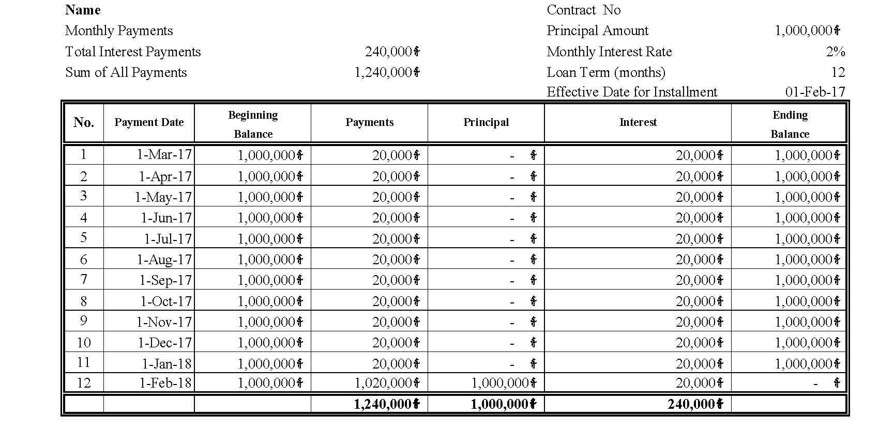

Note: AC should select method which borrowers pays interest every month and pays all principle at the maturity since this method is easy to calculate interest which make borrowers more understandable.
      - Balloon Repayment Loan:
It is a loan repayment type which requires the famer to make principal payment once per three months or per six months. It is commonly used for the agriculture business in which are AC members need to collect and sell their agriculture products per every three months or six months. At the end of the term, the remaining balance is due as a final repayment.

Balloon Payment Principal / Three months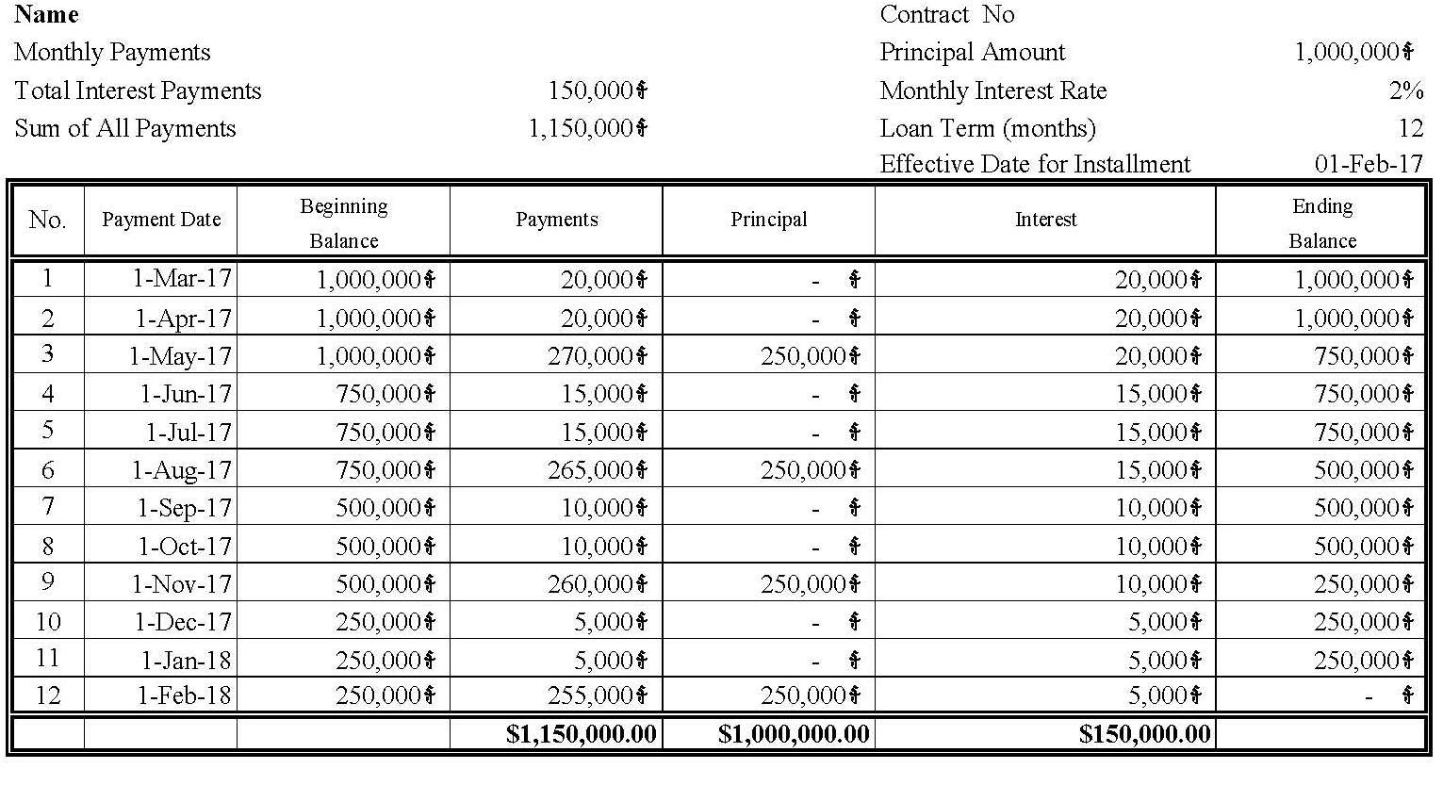

Balloon Payment Principal / Six months
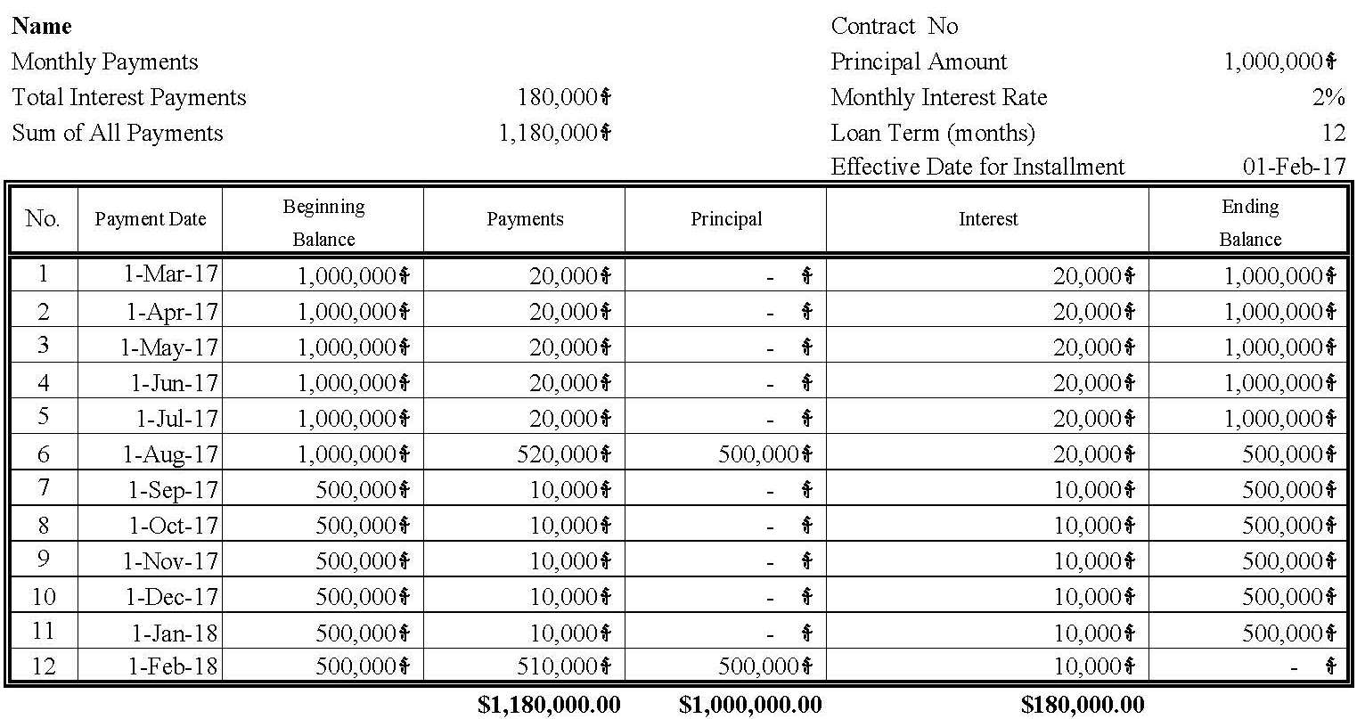

      - Installment Repayment Loan:
Many loans are repaid by using a series of payments over a period of time. These payments usually include an interest amount computed on the unpaid balance of the loan plus a portion of the unpaid balance of the loan. This payment of a portion of the unpaid balance of the loan is called a payment of principal. There are generally two types of installment repayment loan (Even Principal Payments and Even Total payments).

- Even Principal Payment or Equally Monthly Principal Installment
With the even principal payment schedule, the size of the principal payment is the same for every payment. It is computed by dividing the amount of the original loan by the number of payments.
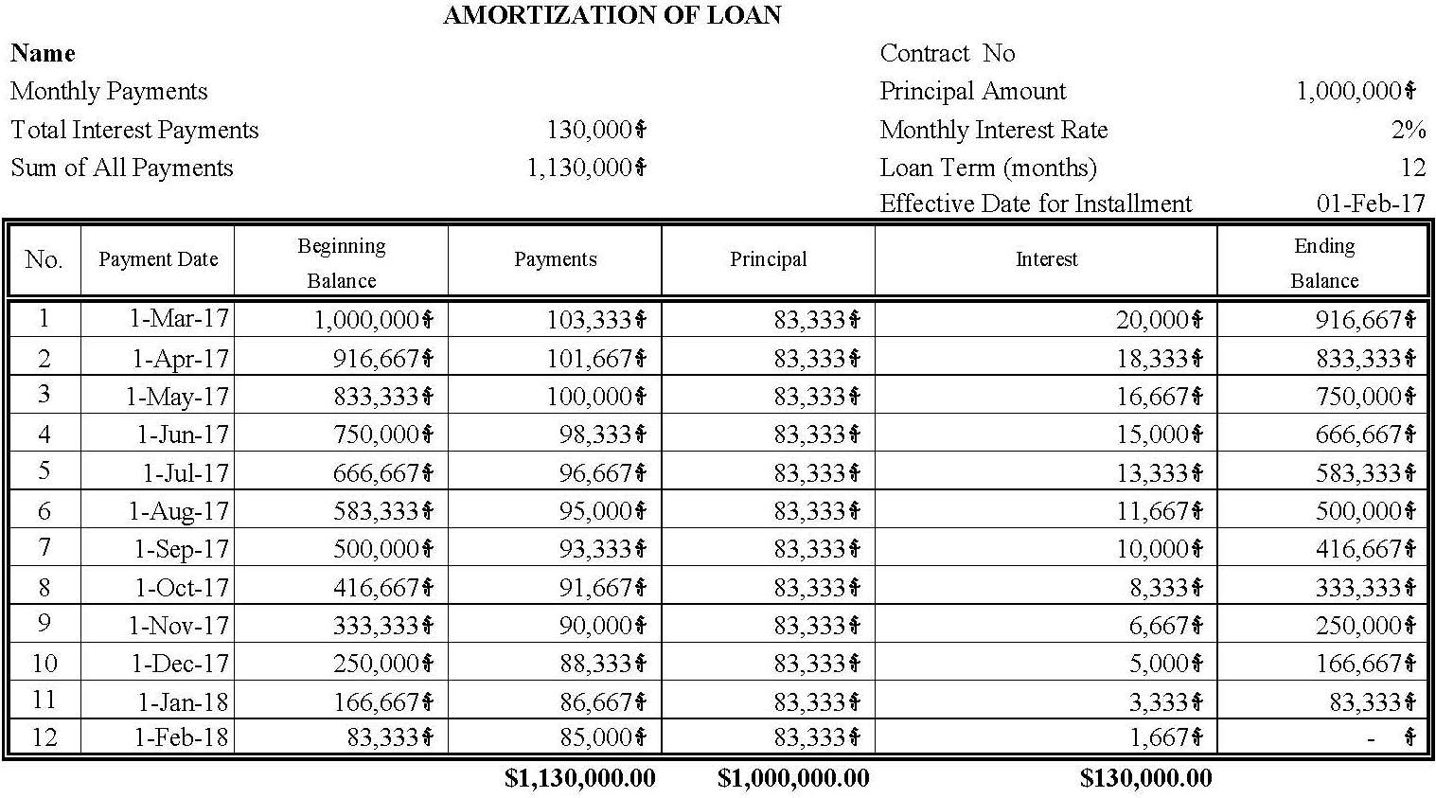

- Even Total Payment or Equal Monthly Payment

The even total payment loan is comprised of a decreasing interest payment and an increasing principal payment. The decrease in the size of the interest payment is matched by an increase in the size of the principal payment so that the size of the total loan payment remains constant over the life of the loan .As shown in example, the interest payment decreases as the unpaid balance decreases. The remainder of the loan payment is principal payment.

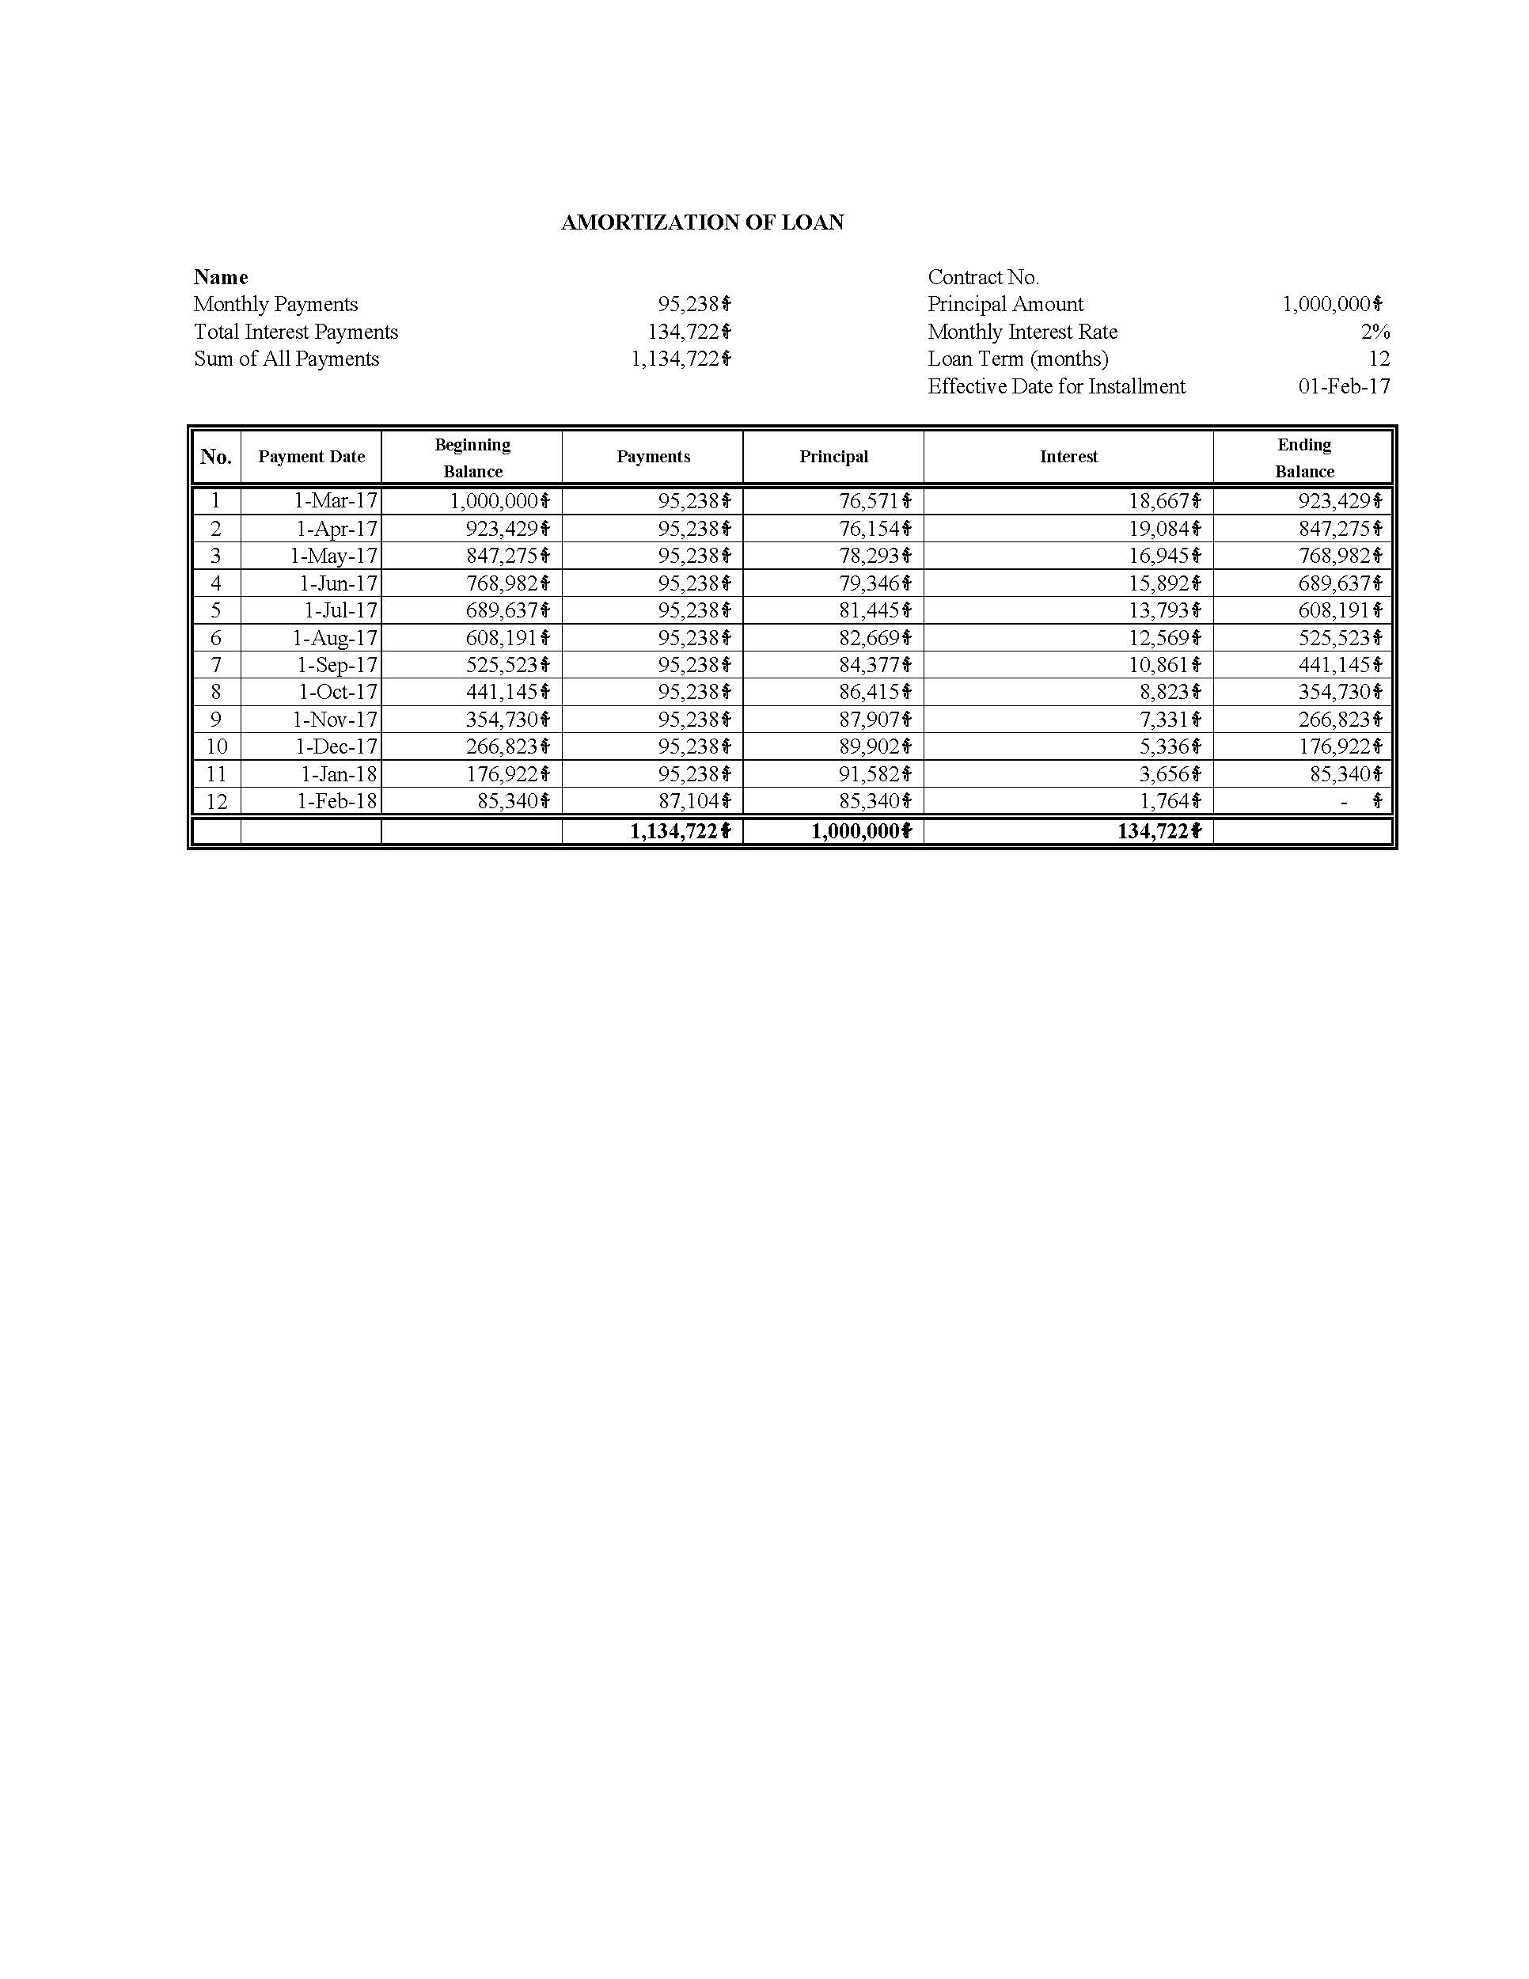

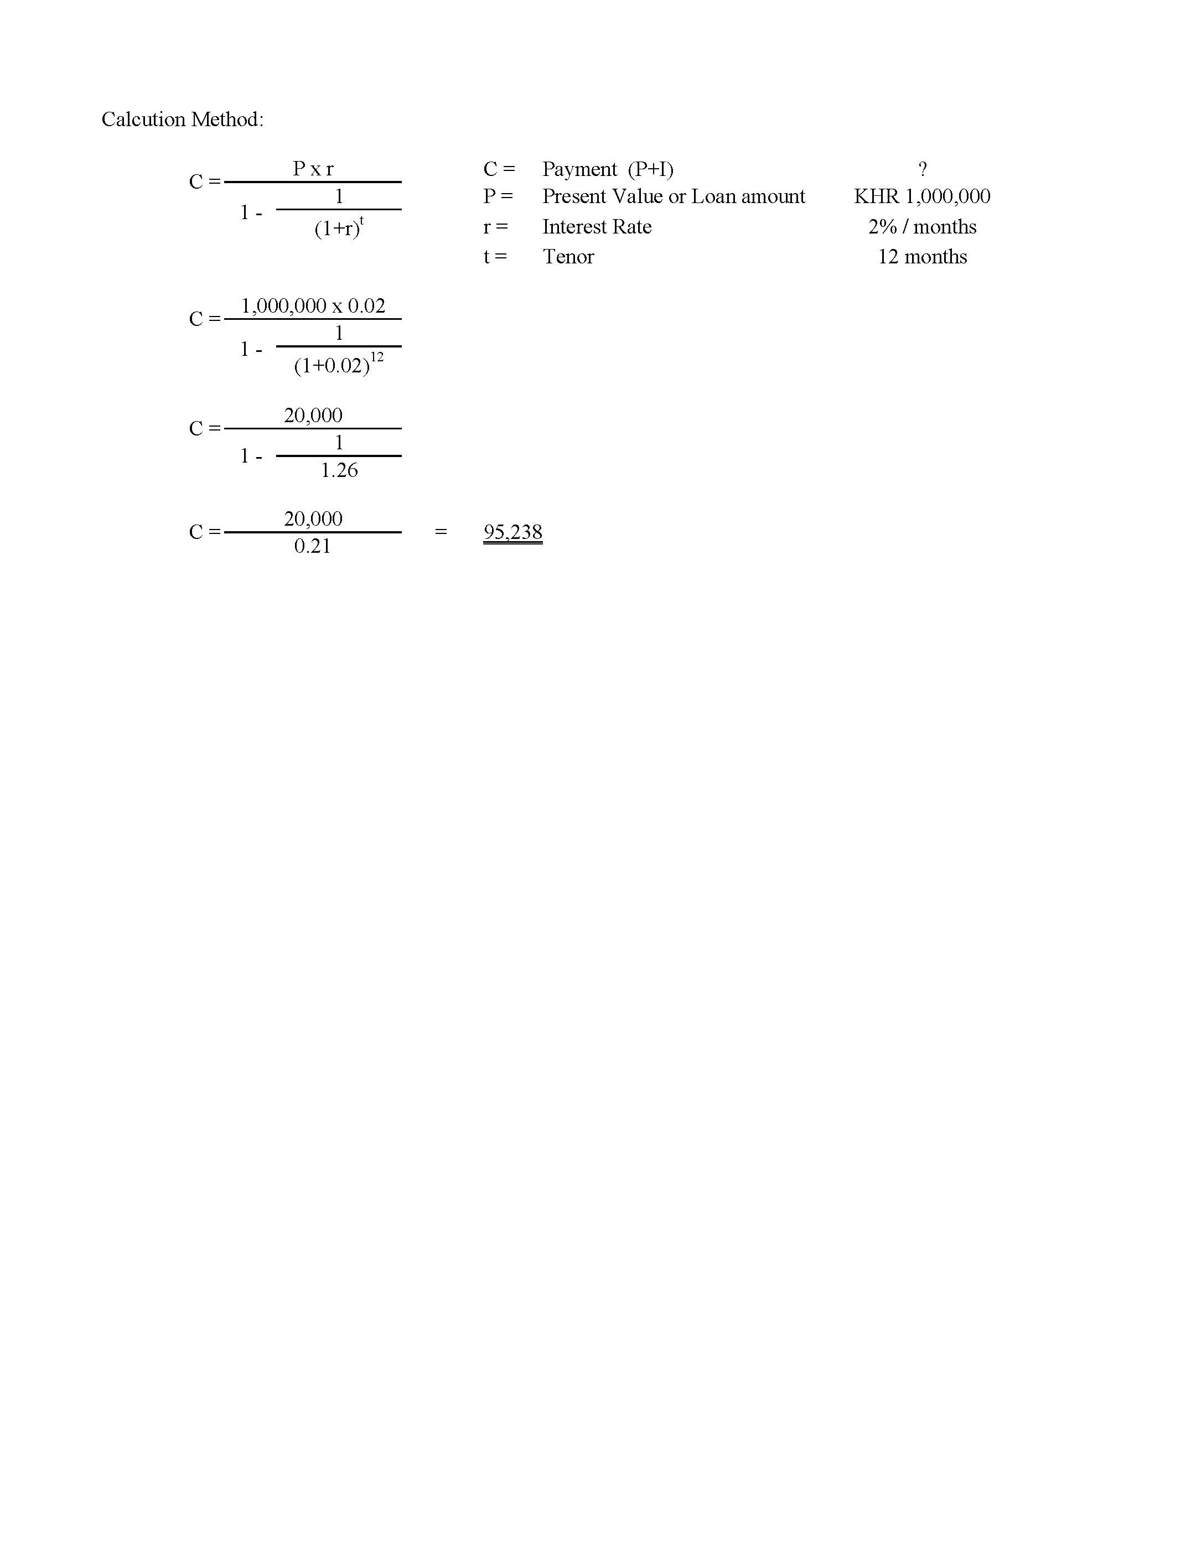

1.7 Step7: Disbursement Loan
There are various methods that can be used for loan disbursement. For those micro-finances with better facility they tend to prefer the disbursement via customer account which required AC members to have bank account. Anyway, for some micro-finance their customers are AC members and their offices placed in rural area so disburse loan to AC member as cash which is not complicated.
Commonly, AC provides loans in cash directly through a cashier. In the future, AC should persuade member to open bank account at the bank which AC has account so that it is easy to transfer loan to the member.
1.8 Step8: Filling Loan Document
After the loan has been disbursed into AC members' account or in cash, Credit Agent need to well-kept all the famer's document properly. Commonly, Credit Agent shall create credit folder for each loan applicants and categories types of document as the following:
a. AC members’ information:
At the left hand side of the folder
- Copy of famer ID
- Copy of title deed No.___ of Mr. and Mrs. (Specify number if more than 1 copy)
- Mortgaged contract stamped by Sangkat/Khan issued on...
- Other guarantee
- deposits/Margin deposit
- Correspondence information (specifies if any)
b. Loan document Credit appraisal:
At the right hand side
- Attached full or part of financial statement analysis (including borrower’s
- Business plan, cash flow projection and so on)
- Loan approval memorandum
- Loan contract (specify if related to other borrowers)
- Loan application
- Loan Monitor/review
- Loan review report (updated for business and collateral visit)

Flow Chat of Lending Process
- Receive expense voucher from Accountant to give cash to loan-taker.
- Receive cash from Cashier
7
6
1
Cashier

AC Members
(Loan-taker)

5
4
3
2
- Transfer all documents of loan approval or reject to cooperative staff.

- Prepare document for member to get loan from Cashier
Accountant
- Give offer letter to farmers
- Prepare loan agreement based on the offer letter and thumbprint by farmers and representatives of Cooperative and get it certified by local authority.
- Prepare document for loan disbursement
- Get supporting documents from farmers
- Review all documents and the conditions
- Complete loan application, and farmers sign or thumbprint on application.
- Site visit business and the pledged property
- Recommend for loan approval and submit loan application to supervisor.

Credit Agent
- Review all documents and conditions
- Recommend for loan approval and submit loan application to credit committee.
Vice-Chairman of Credit Committee

Chairman of Credit Committee
- Review all documents and conditions
- Loan approval or reject.
        - Loan Monitoring:
The success or failure of any financial institution is closely tied to the quality of its loan portfolio and its loan monitoring system. The assessment of repayment capacity and the creditworthiness of an applicant provide the basis for good loan decisions and thus, portfolio quality. Good loans may turn bad however. In agricultural lending, there are particular risks and thus careful monitoring to avoid default is crucial. A monitoring system provides the information needed to oversee loan portfolio quality at any given time, identifying potential problems at the earliest moment possible.
2.1 Open communication between the lender and the famer is essential for effective loan monitoring. Some famers do not like to tell the loan staff about problems they may face in repaying the loan. The establishment of open communication can help ensure that problems are communicated as soon as they arise.
2.2 Loan files must contain all the documents (loan application, loan assessment, collateral records, memos, loan agreement, etc.) which provide a loan staff and other interested parties with a complete historical and on-going record of the relationship between the lender and the famer. These files are the backbone of a loan monitoring system.
2.3 Computerization should be introduced, if it is not already in place. Although in principle loan tracking can be done manually, this will be difficult beyond a certain number of famers with highly individual repayment schedules and loan terms. An obvious advantage of computerized loan monitoring systems is that reports can be generated automatically. As a speedy response to loan default is vital for maintaining a sound loan portfolio, automation can help to identify problem loans at a very early stage, allowing for immediate corrective action.
Various strategies can be employed to monitor loan performance. Generally, an agricultural lending institution should stay in touch with their famer through the loan staffs. The loan staff can capitalize on the relationship established during the field visit, the appraisal process, and possibly through earlier business contacts. This is not only prudent loan monitoring practice; it is also good famer relations.

2.4 Site visits is the most effective way to obtain information about the current performance of the famers. This gives an opportunity to uncover organizational and operational problems and discuss the current risk management strategies employed by the famers .On-site visits should be timed to coincide with crucial moments in the famers’ agricultural production cycle, e.g. when crops are germinating, when fertilizers are being applied or just before harvest. Pre-harvest visits are particularly useful to assess repayment potential and make the AC members feel monitored in their repayment performance.
2.5 Monitoring actual loan repayment performance is also another way specifically for those AC members who are infrequent contact with lending institution.
        - Loan Delinquency Management
Even though most AC members plan to make timely loan payments, unforeseen circumstances sometimes results in late payments. Therefore, AC members should compare the penalties associated with late payments and grace periods that are specifically written in loan documents. More significantly, AC members should also be aware of the conditions under which the loan is considered as delinquency.

  - Definition
Delinquency commonly refers to a situation where a famer is late or overdue on loan payment obligation. It can also be called arrears or late payment, loan portfolio at risk. In other word, a famer who does not make the schedule payment on the agreed date is considering to be in loan delinquency. Similarly, if an installment is supposed to be paid on 7th of March, 2017 and if it is not paid on that day, then on 8th of March, the loan is classified as delinquency.
  - Cause of Delinquency
Internal Factors
- Typically, it happen AC members failure to adhere to set out lending policies; this whereby a Credit Agent grant loan to famers without the full considerations agreed in the lending policy of the institution yet because of past experience and relationship. Plus, the economic conditions are dynamic as such granting a loan basing on past experience may result in loan delinquency.
- Loan application: the product does not meet the famers’ real need. There may be a mismatch in maturity, terms and conditions, loan size etc. The famers are not well advised on the product characteristics.
- Loan assessment and loan proposal: The Credit Agent fail to properly assess the repayment capacity and/or repayment willingness of the famers. Failure to propose adequate terms and conditions (including repayment dates) that meet the needs, demands and cash flow of the famers.
- Loan approval: Credit committee decisions are influenced by pressure to meet disbursement targets; decisions are subjective, based on the level of trust in the Credit Agent and lacking an objective credit review.

External Factor
- Individual crisis: unpredicted individual crisis may lead to loan delinquency. The agricultural famers are unable to handle their obligations due to loss of income (for instance due to a bad harvest), death of a near relative, fired from work, salary reduction among others. This will lead to the profits generated or the loan amount being used to cater for those unanticipated commitments hence failure to meet loan repayment deadlines., job loss, illness or personal injury of the famers or a close relative;
- Natural disasters: Natural disasters such as floods, and drought may hinder the monitoring the progress of the project, for example appraisal visits may thwart by such disasters. This may also affect the infrastructure of where the famers’ project is geographically located. For instance if the famers were in agriculture and have been affected by one or more of the disasters, their yields will be suppressed hence the famers may look for other secondary sources of repayment which requires considerable amount of time, thus delayed repayment.
- State of the economy: business cycles (boom, depression and recovery) affect delinquency in several ways. In a depressed economy, the probability of late repayment is relatively high as compared to an economy at boom or recovery stages of business cycle. This is mainly because economies in depressed state face liquidity challenges hence the expected returns from famers’ projects will be negatively affected leading to delinquency.
  - Collection Process in case Loan Delinquency or Loan Late Payment
(Please refer to Article 7 of Internal Regulation for Credit Business of Agricultural Cooperative)

        - Loans Default Management/ Solution
Loan delinquency is a failure to make loan payments when they are due. Extended delinquency can result in loan default. Loan default is the failure to repay a loan according to the terms agreed to in the loan agreement. To make it simple, a loan is delinquent when a payment is late. A delinquent loan becomes a defaulted loan when the chance of recovery becomes minimal.
First, we need to classify the loan default customers into one of the following four categories:
- Willing and able to repay
- Willing but unable to repay
- Unwilling but able to repay
- Unwilling and unable to repay

Then we may take actions as following:
- Willing and able to repay
Management could allow Credit Agent to receive payment, even partial payment, at the famers’ business or home.
- Willing but unable to repay
Rescheduling should be considered for famers with a very good excuse. This means that the principal, interest due, and penalty due are added up as the starting balance on a new loan, for which the famers signs a new loan contract. Rescheduling can, however, hide a problem that can resurface in a worse condition; even encouraging delinquency .The day of reckoning comes when repayments start again. Yet, it does not have any guarantee that late payments will not occur again.
- Unwilling but able to repay
We may pursue legal action or inform the community and influential persons of famers’ unwillingness to repay. Their names can be publicly posted. Probably, community leaders can push them to pay. Community leaders can be informed that we will stop lending in the neighborhoods if arrears are too high. The entire neighborhoods could lose because of several persons’ unwillingness to honor their legal obligations. Handing famers over to debt collectors should be considered, but the institution then loses most of its leverage.
- Unwilling and unable to repay
They are best referred to debt collectors or written off or another solution is to put the collaterals on sale to get money back to settle loan.

